Project Planning Phase
Project Planning Template (Product Backlog, Sprint Planning, Stories, Story points)
Date | 14 October 2026
Team ID
Project Name | Automated Network Request Management System
Maximum Marks | 5 Marks

Product Backlog, Sprint Schedule, and Estimation (4 Marks)
Use the below template to create product backlog and sprint schedule:
Sprint | Functional Requirement (Epic) | User Story Number | User Story / Task | Story Points | Priority | Team Members
Sprint-1 | Service Catalog | USN-1 | Create 'Network Request1' catalog item & category | 2 | High | Pooja Reddy
Sprint-1 | Service Catalog | USN-2 | Add 7 variables (Requested For, Mobile, Connection Type, Amount, etc.) | 3 | High | Pooja Reddy
Sprint-1 | UI Validation | USN-3 | Build Catalog UI Policy 'visible/hide of ID field' | 3 | High | Pooja Reddy
Sprint-1 | Data Model | USN-4 | Create custom table Database Table1 (u_database_table1) | 3 | High | Pooja Reddy
Sprint-1 | Data Model | USN-5 | Configure auto-numbering and sys_relationship on custom table | 3 | Medium | Pooja Reddy
Sprint-1 | Variable Set | USN-6 | Create 'Requester information1' variable set and link to item | 2 | Medium | Pooja Reddy
Sprint-2 | Flow Designer | USN-7 | Build Flow 'Network Request1' with trigger & 'Get Catalog Variables' | 3 | High | Pooja Reddy
Sprint-2 | Flow Designer | USN-8 | Configure 'Create Record' action mapping pills to u_database_table1 | 3 | High | Pooja Reddy
Sprint-2 | Approval Flow | USN-9 | Configure 'Ask for Approval' & 'If Approved' branch logic in Flow | 3 | High | Pooja Reddy
Sprint-2 | Notifications & Task | USN-10 | Configure 'Send Email' alerts and 'Create Catalog Task' fulfillment | 5 | High | Pooja Reddy
Project Tracker, Velocity & Burndown Chart: (4 Marks)
Sprint | Total Story Points | Duration | Sprint Start Date | Sprint End Date (Planned) | Story Points Completed | Sprint Release Date (Actual)
Sprint-1 | 16 | 5 Days | 05 Oct 2026 | 09 Oct 2026 | 16 | 09 Oct 2026
Sprint-2 | 16 | 5 Days | 10 Oct 2026 | 14 Oct 2026 | 16 | 14 Oct 2026
Velocity:
Total Story Points Completed = 32 | Number of Sprints = 2 | Team Velocity = 16 Story Points per Sprint.
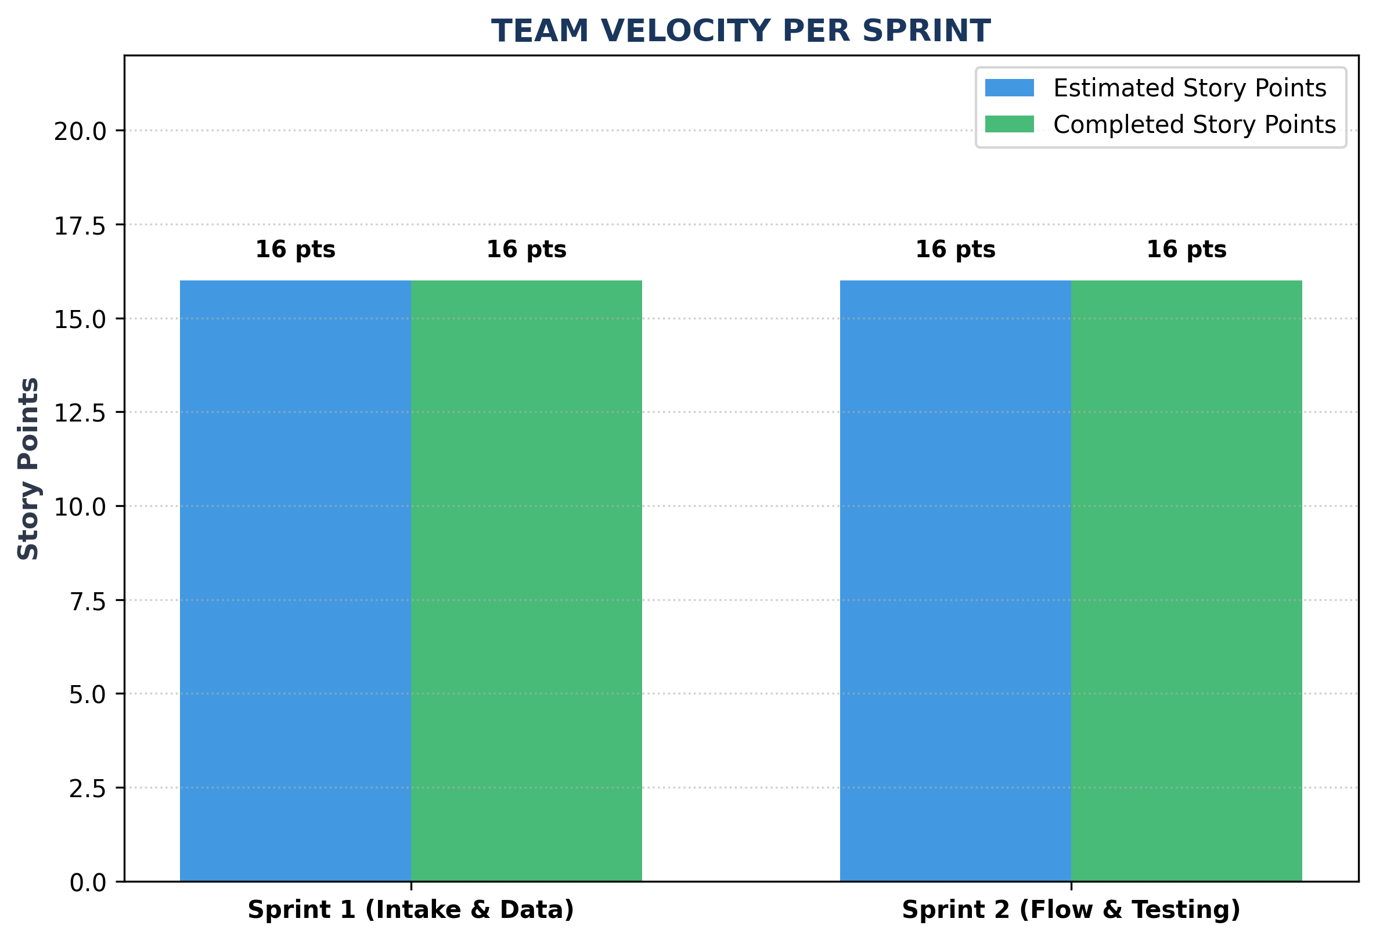
Figure 4.1: Team Velocity Chart per Sprint
Burndown Chart:
A burn down chart is a graphical representation of work left to do versus time. Below is the sprint burndown chart:
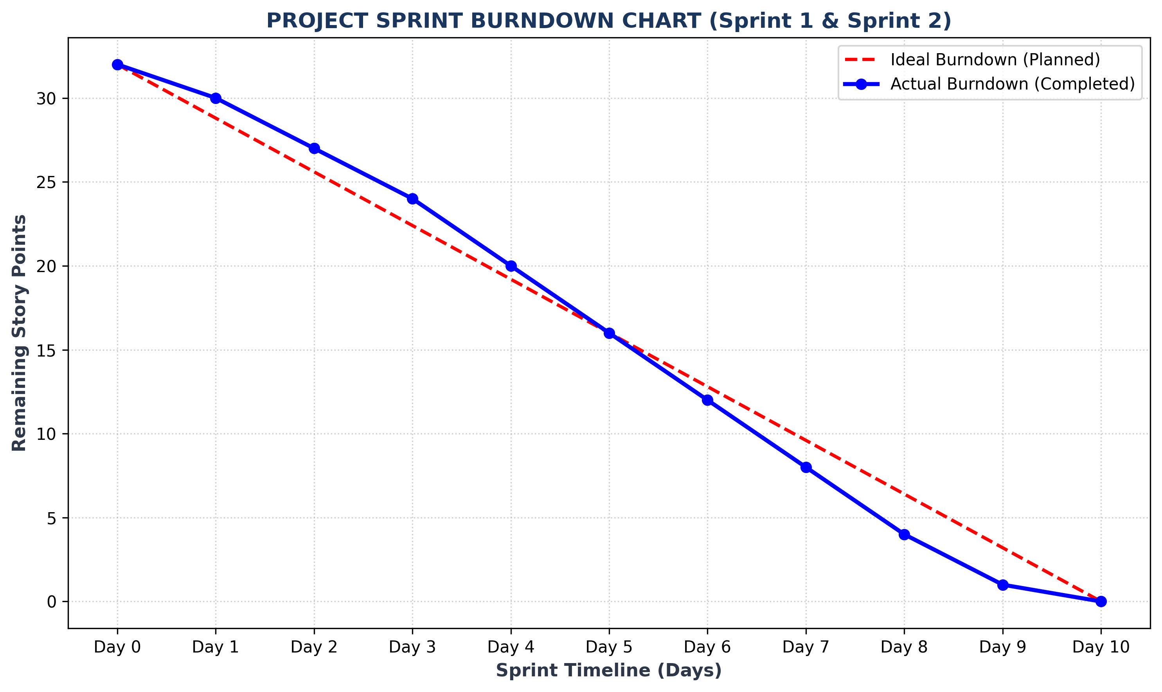
Figure 4.2: Sprint Burndown Chart (Planned vs Actual)

